Instructions for Using the Online Occupational Safety and Health Digital Learning Platform

1. Navigate to the Occupational Safety and Health Digital Learning Platform website at https://isafeel.osha.gov.tw/mooc/index.php

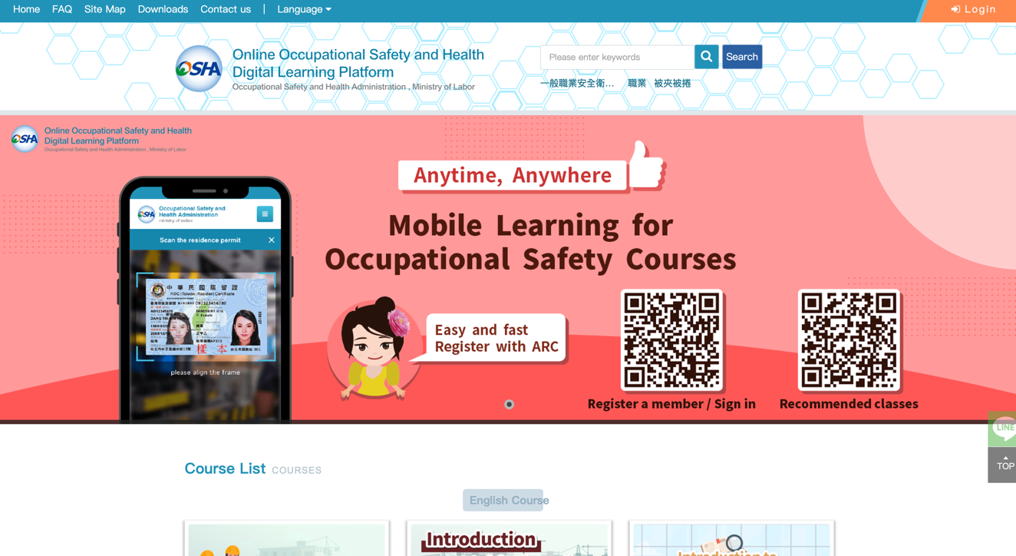

2. For instructions on how to log in, register, or use the platform, please download the "E-learning Platform English Manual" from the Downloads section. Follow the instructions in the platform manual.
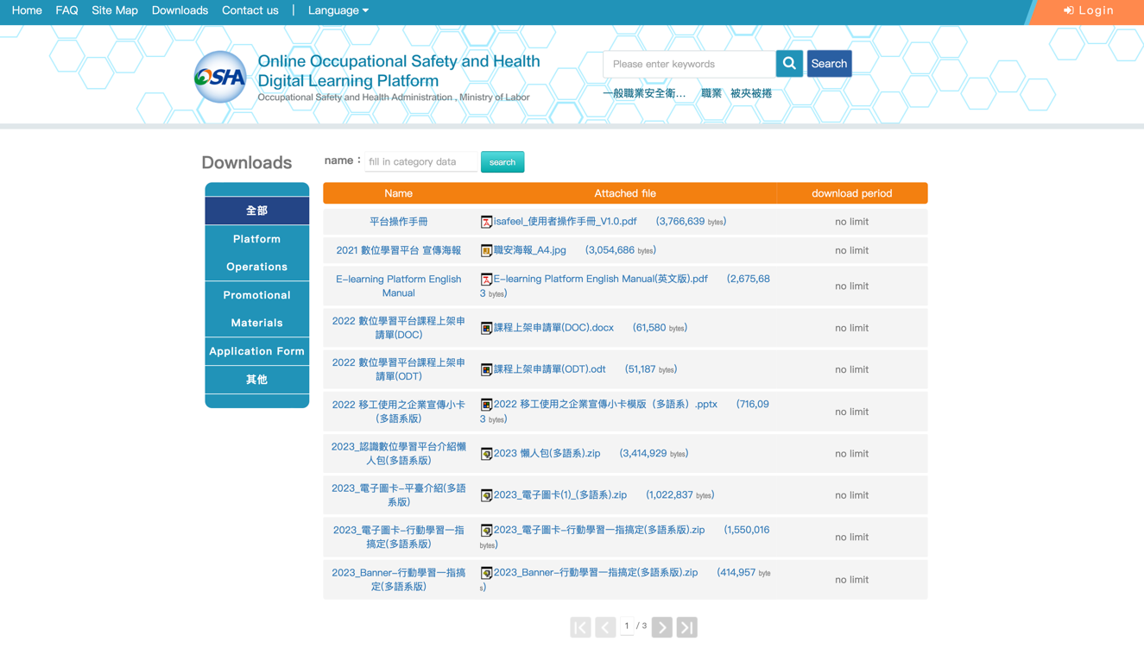

3. After completing the registration, log in.

4. Enter your user ID, password, and verification code.
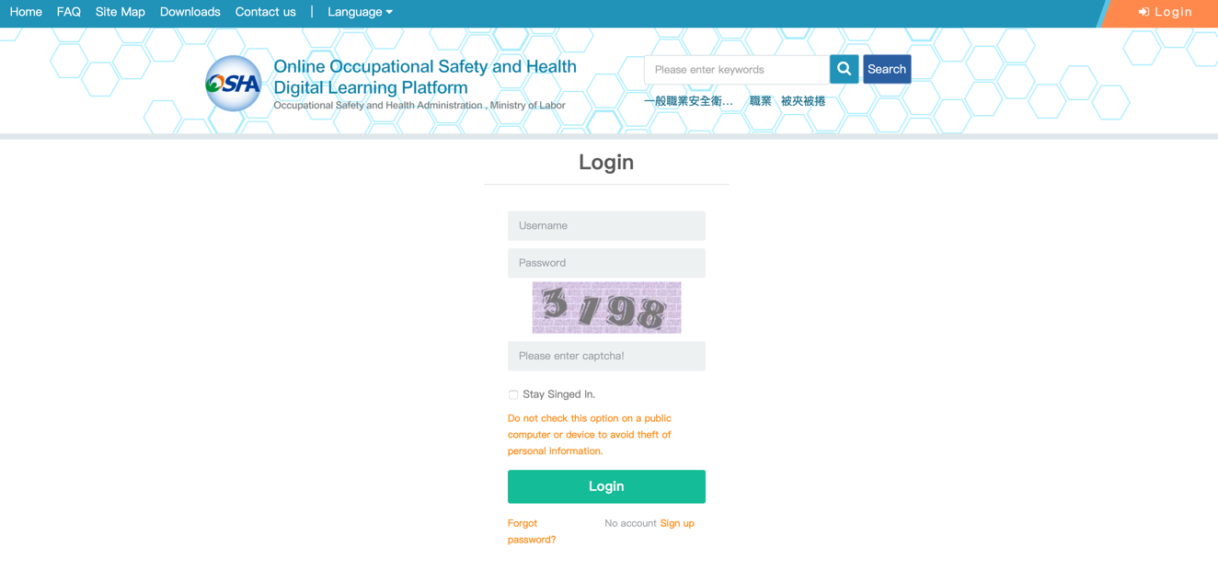
5. In the Course List on the homepage, you need to complete the courses designated by TSRI.
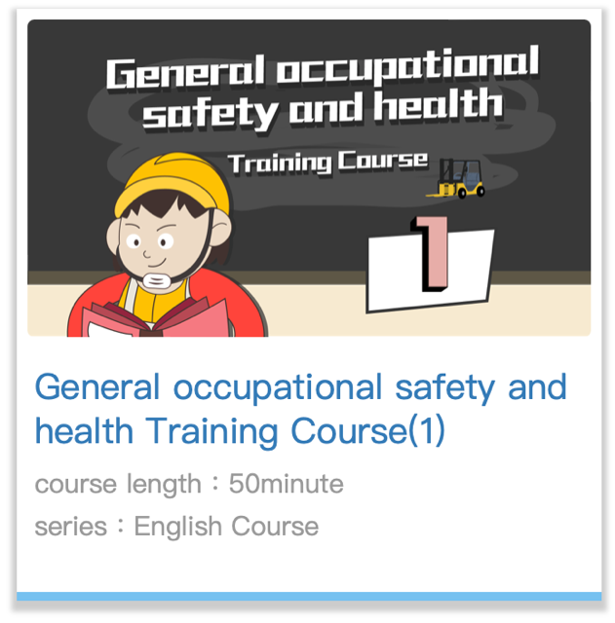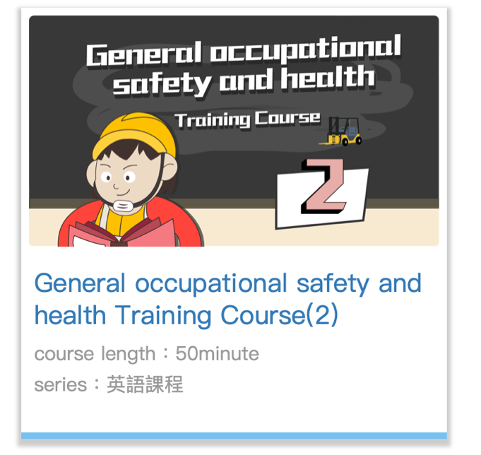


6.Click ”Course Registration”
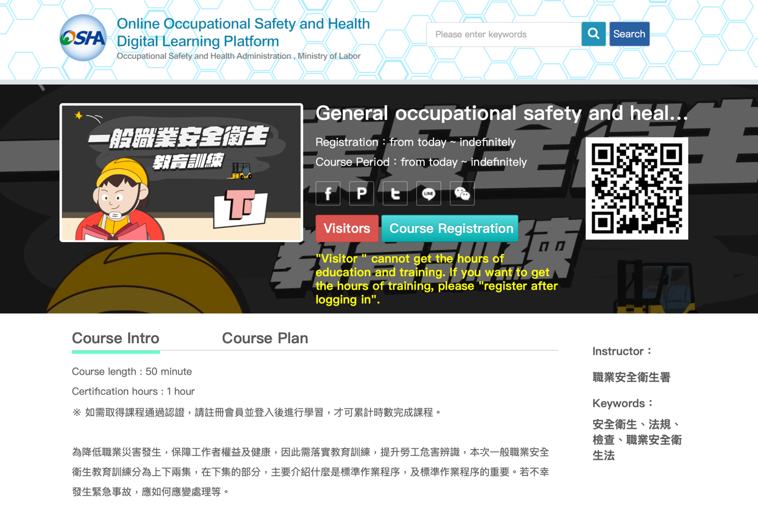
7.Click ”Go to class”
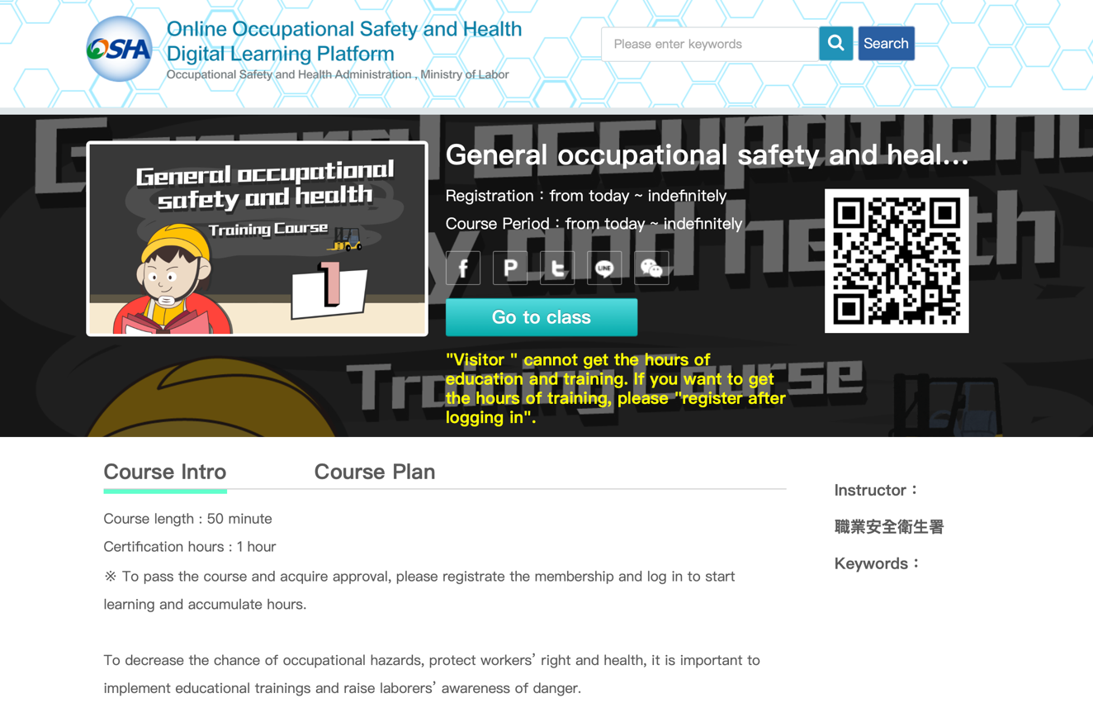
8. After completing all the relevant courses designated by TSRI and passing the tests, click "Study resume" in the [Personal area].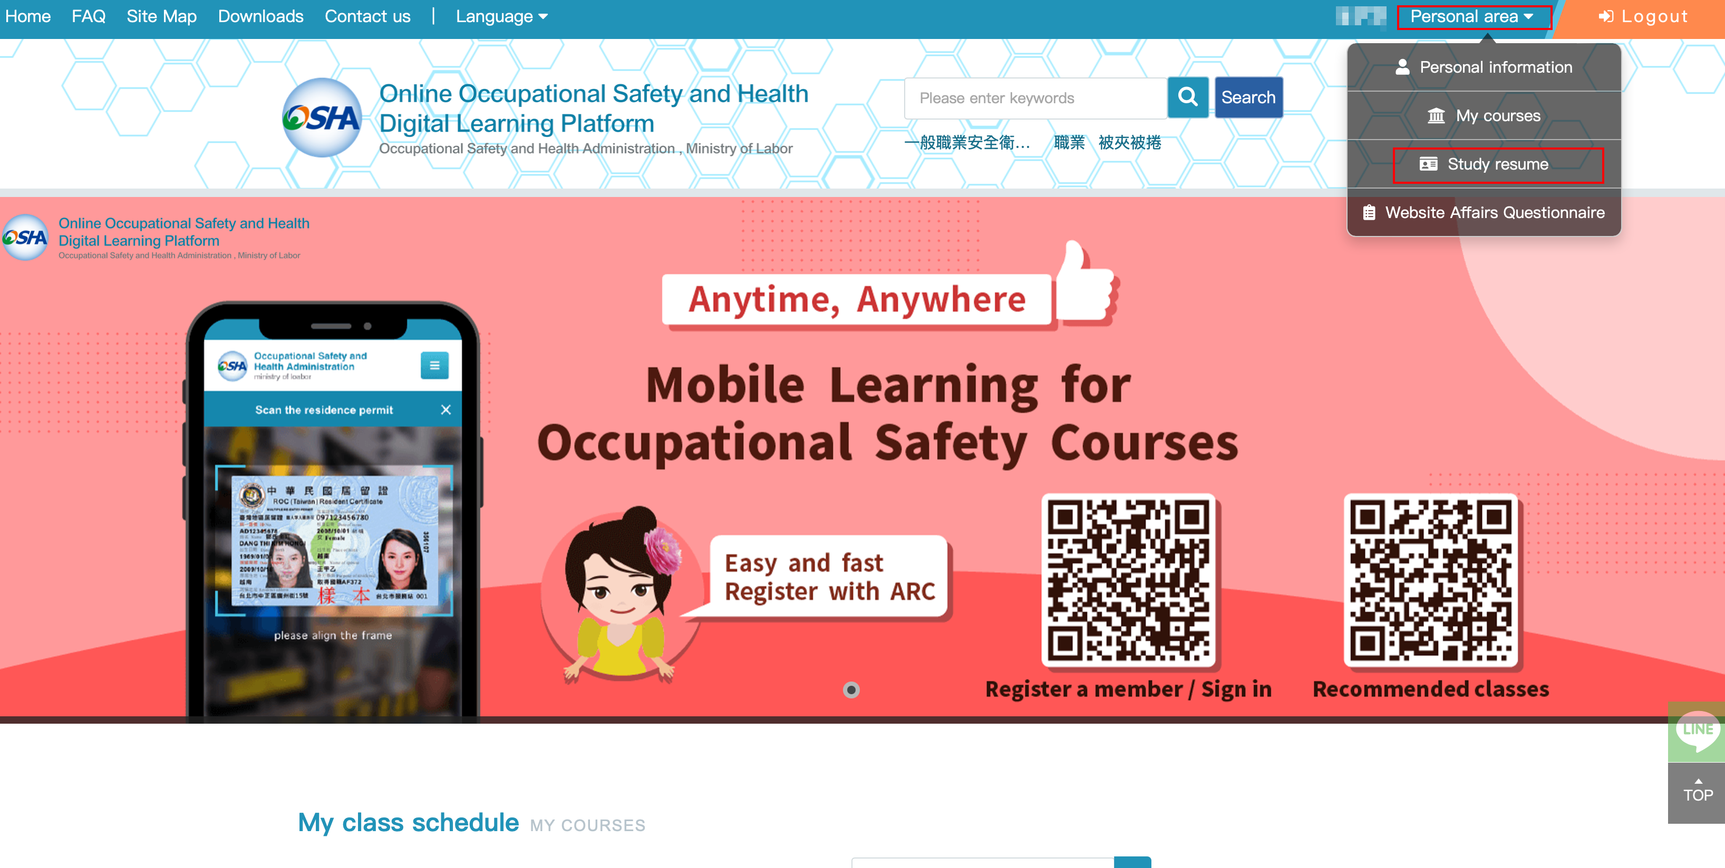

9. Click ”Print learning records”
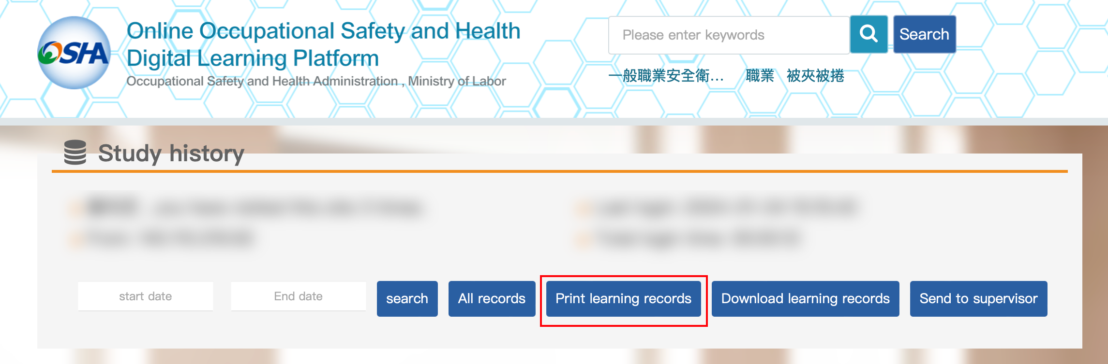

10. Please print out the Certificate of Completion, sign your name in the blank space, and submit it to the person in charge at the time of check-in for physical courses.



